Being An

G E N E R A L D E N O I N T I N G

for the likke{ of

Jon Mocket
Iycob Creed
Abram Hil{
Moll Darby
Mary Onvery
Mary Awlbatch
Anni Awlbatch
Li{ Frogden
Merry Fletch
Mary Havery
James Godshelp
Lizabeth Marrin
Mag Marble
Meg Kones
Iooliet Toogood
Easter Belcher
Iane Towe{
Alice Makeney
Fann Hawe
Saly Larch
Judith Quacer

1 For any ailment, complaint, overlook, Sleep-Cerses, Soured Cream or thing that such folk shall need, if they should come afresh and bother you; have them come to you in the first Hour after noon on a Woodensday, for the Spyrit has come used to getting such Exorcise in that Hour, upon that Day.

2 The kitchin must be dark and smocing; have them light a dry pan on a hot flame afore they come and bring it to your door, and then set it down on the spoiled flag, where John cracked it on the day of my Father's funeral; and set some common Grass picked Years ago. Have this page laid Open most Visible before the Circle, and about your neck hang a Board with the Name of Them Above who is to Visit you, and also You shall write

ISS A JACK ADAM AND A LIAR

below it. You shall tell them to run twenty times about the House afore they Enter; and you shall Watch their eyes as they Come to the Kitchin, and how they Sniff the smells, and Blink at the Smoke; and how their Eyes shall light upon the Circle, and How they Feer what is to be done in their Name; and how their Eye fall upon the words about your Neck; and if their Eye widen, and you see the Whites dance, and move from the East to the West in a way of Knowledge you shall Strike them from the List, and return to Them their money, and Tell to them that Nought can be done for Them, and that Spyrit has taken Dislike to them, afore sending them into the Day. If they Challenge you on the Boardd, refuse You to Countenance them, and tell them that it be the Spyrit who Wrote it, and that you can Read it not.

3 For those who look yet See not, or continue Not to Read, they Shall have brought to You the Constituents:

Ten Rusks (the receipt matters not, though You should Speak benisons above them, taken from any Psalm you please);

The curd of a goat who Has Acquried the Habit of looking upwards (and of whom There shall always be One or Two in a Herd);

Some of the tart berries which many are Proud to know their origin in the Bogs up by St. Severus' Well, mashed well into Paste and sweetened with ashlar dust and sugar.

4 Waken you the Spyrit or have him come forward in his Hole; he must have been made to Thirst, and will be most Difficult to Keep; see You the Rituals elsewhere to Compel him.

5 Have them kneel at the Outer Door of the Circle, and you within, and draw you the symbol below upon the creature's favourite spot twice, reciting the word below twice and all. When this is done, pour him some milk.

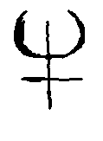
TENET

6 Once this be done, recite the words below twice and stroke those symbols with them twice in all, slow, while he Watches the milk.
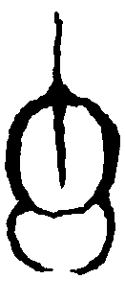
ROTAS
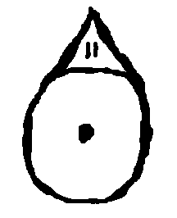
DABLAS

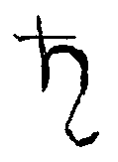
GAOUNUM

7 Speak you now the ritual in which you consecrate your Hand as the Blunt Knife of Abraham, and draw you the symbol below upon His brow, before speaking these words, and the name of they who are visiting you.

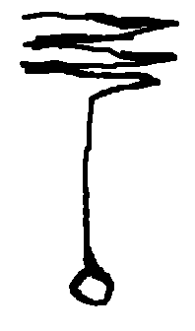
HAVE MERCY ON THIS SOUL

8 You must let the Spyrit scream now, and let the Customer hear to it. When it has ceased Its cursing, you must speak these words for to seal the Ritual, loud and slow and with your Natural authority:

EHEU YOCTUM, EHEU EHEU!

AMAT TUUS

EHEU

TRANQUILAM!

ADHUC MANERE

MUNUOAG

SALBAD

SATOR

TENET

A

C O L D C U R Y

for After{

what Father called

Wintter Fire{

Take you a rusk up at a time and spread the curd thick upon them with your flattest finger; as deep as a child's toe, from North to South.

Take you three specks of berry and make the sign of the Trinity upon the blank page of the curd, for More shall make you Wince.

When all are Eaten, the Customer may leave.

